**ASSIGNMENT-11.4**

**Name:** Harshavardhan

**Htno:**2403A51235

**Batch:**24BTCAICSB11

**Task 1: Implementing a Stack (LIFO)**

**PROMPT:**

1. Write a Python Stack class with push(), pop(), peek(), and is_empty(), using Google-style docstrings and inline comments. Show sample tests with data and suggest an optimized version using collections.deque

**CODE:**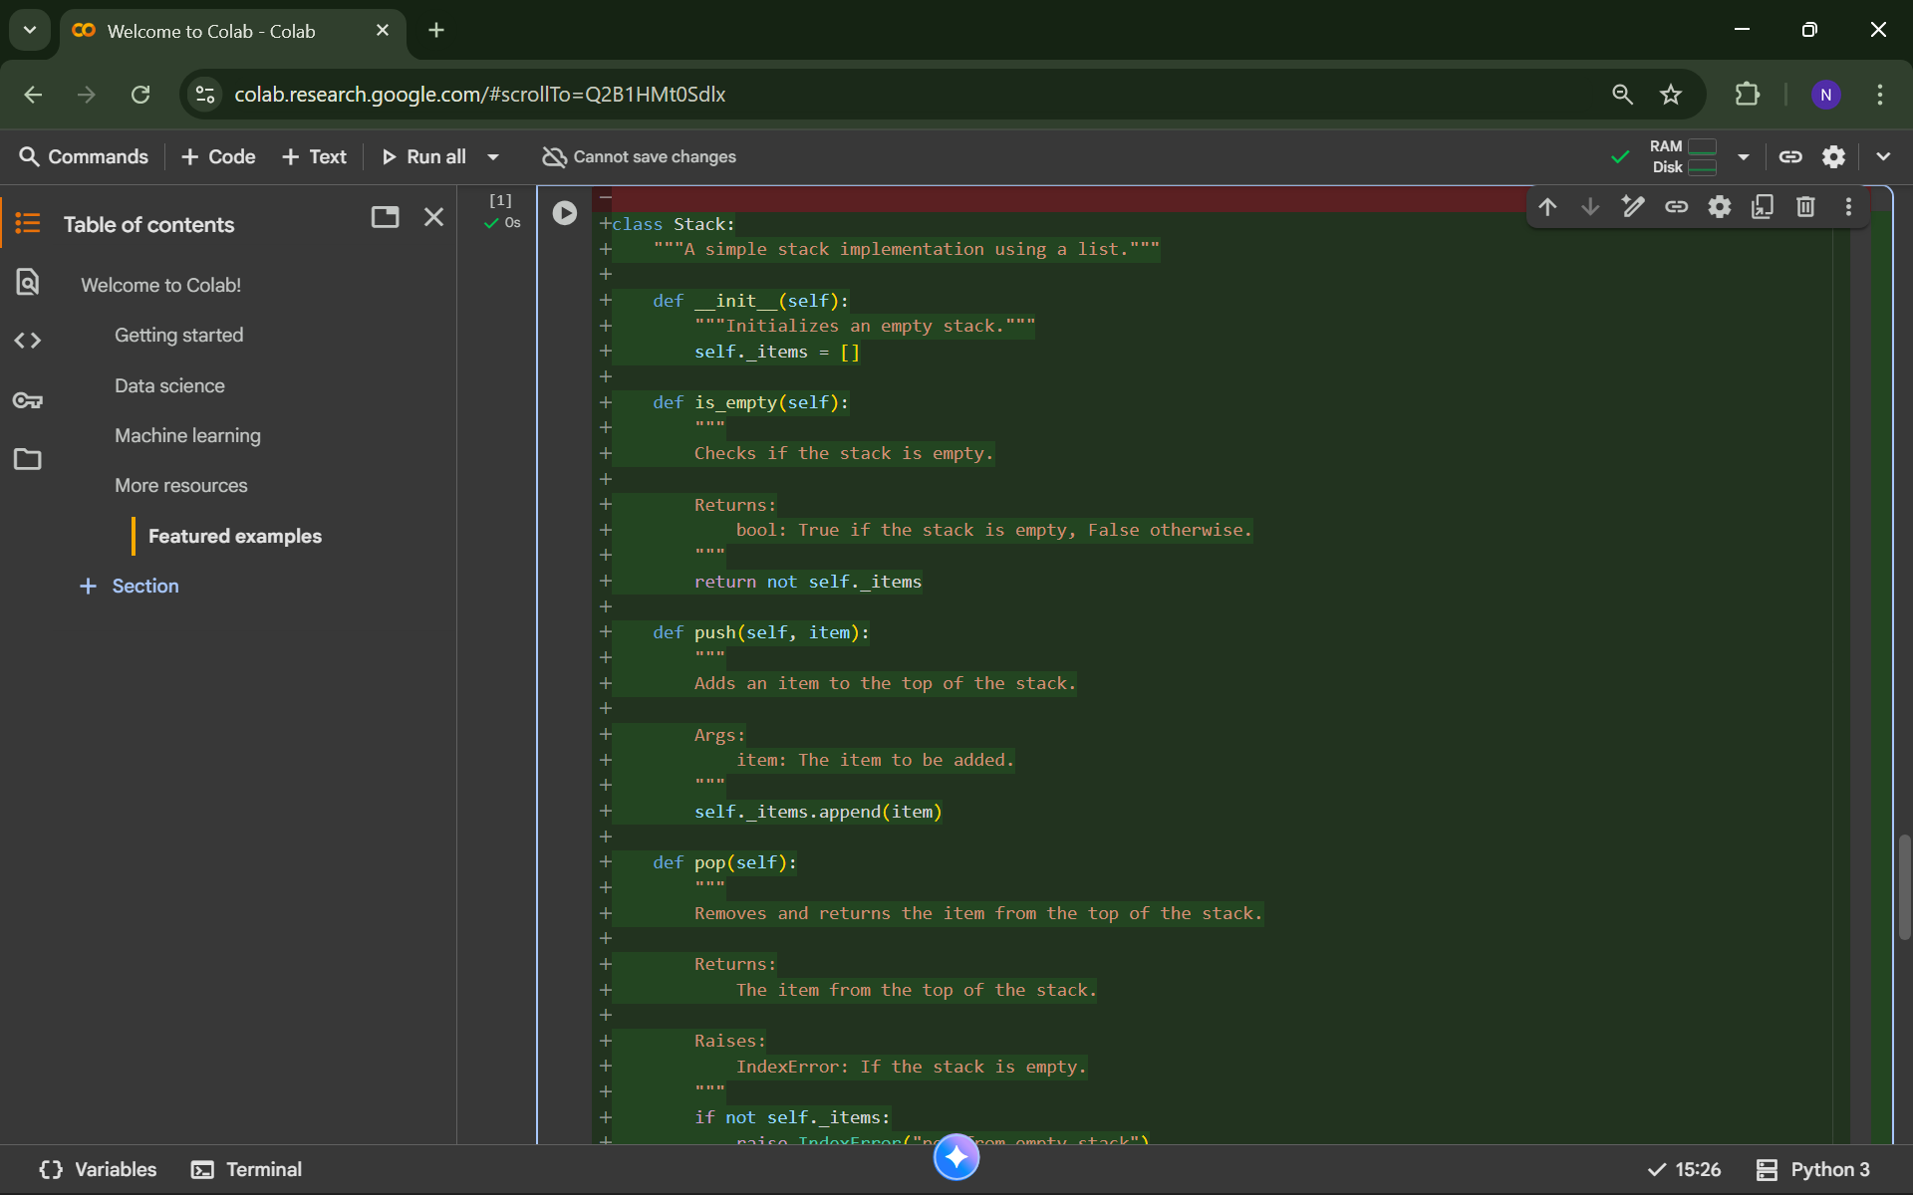

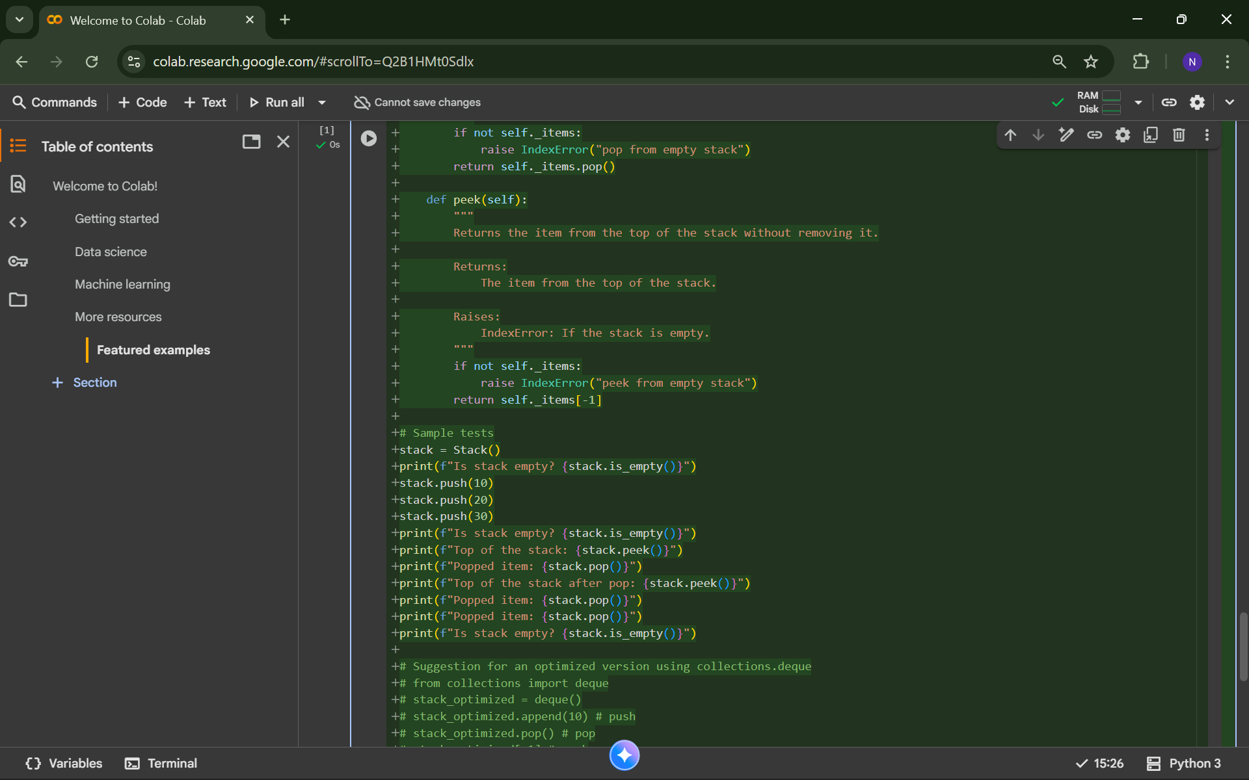

**OUTPUT:**

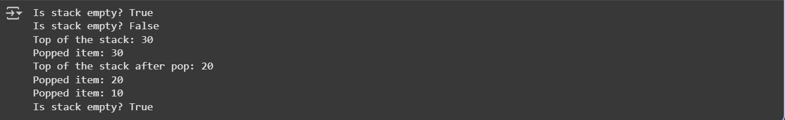

**Task 2: Queue Implementation with Performance Review**

**PROMPT:**

1. Implement two versions of a Python Queue with enqueue(), dequeue(), and is_empty(): one with lists and one with collections.deque. Include docstrings, comments, and compare performance. Show sample enqueue and dequeue operations

**CODE:**

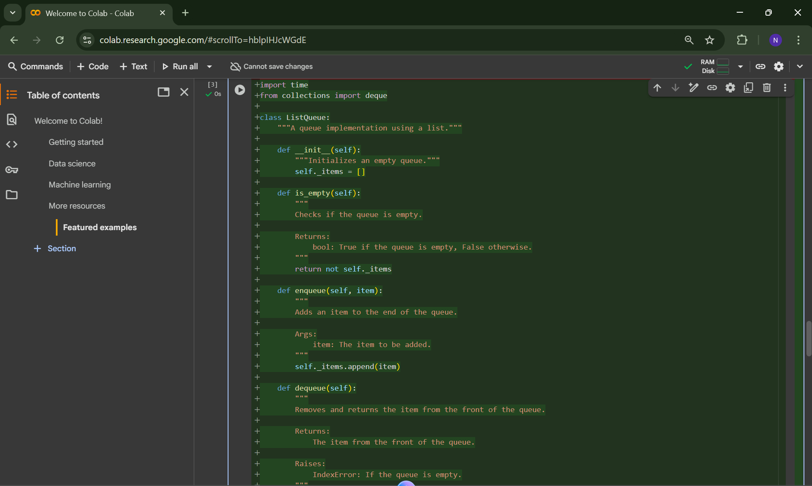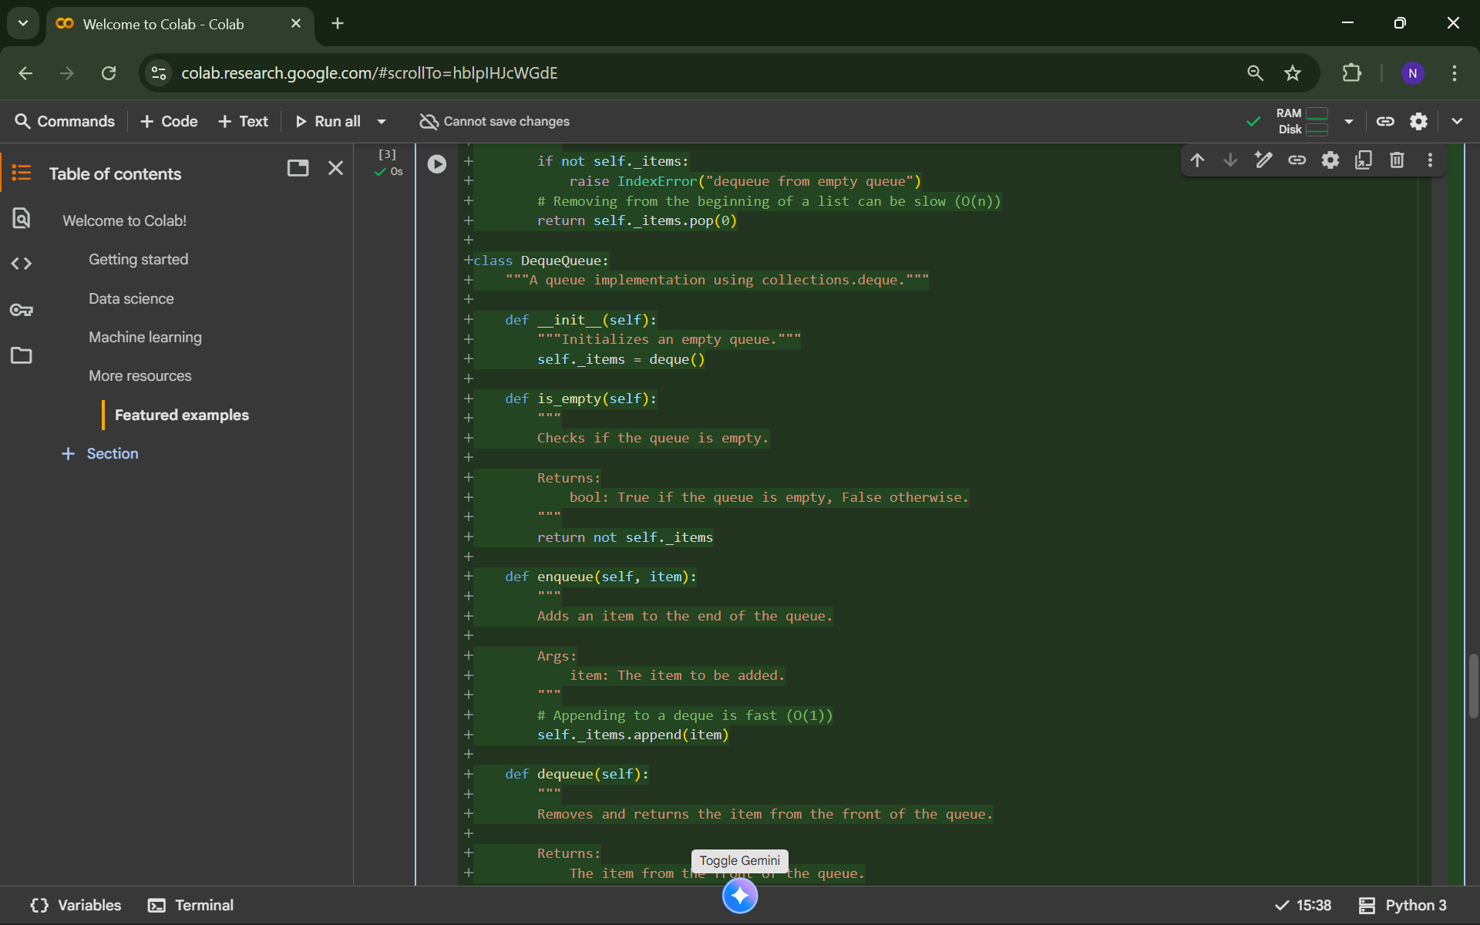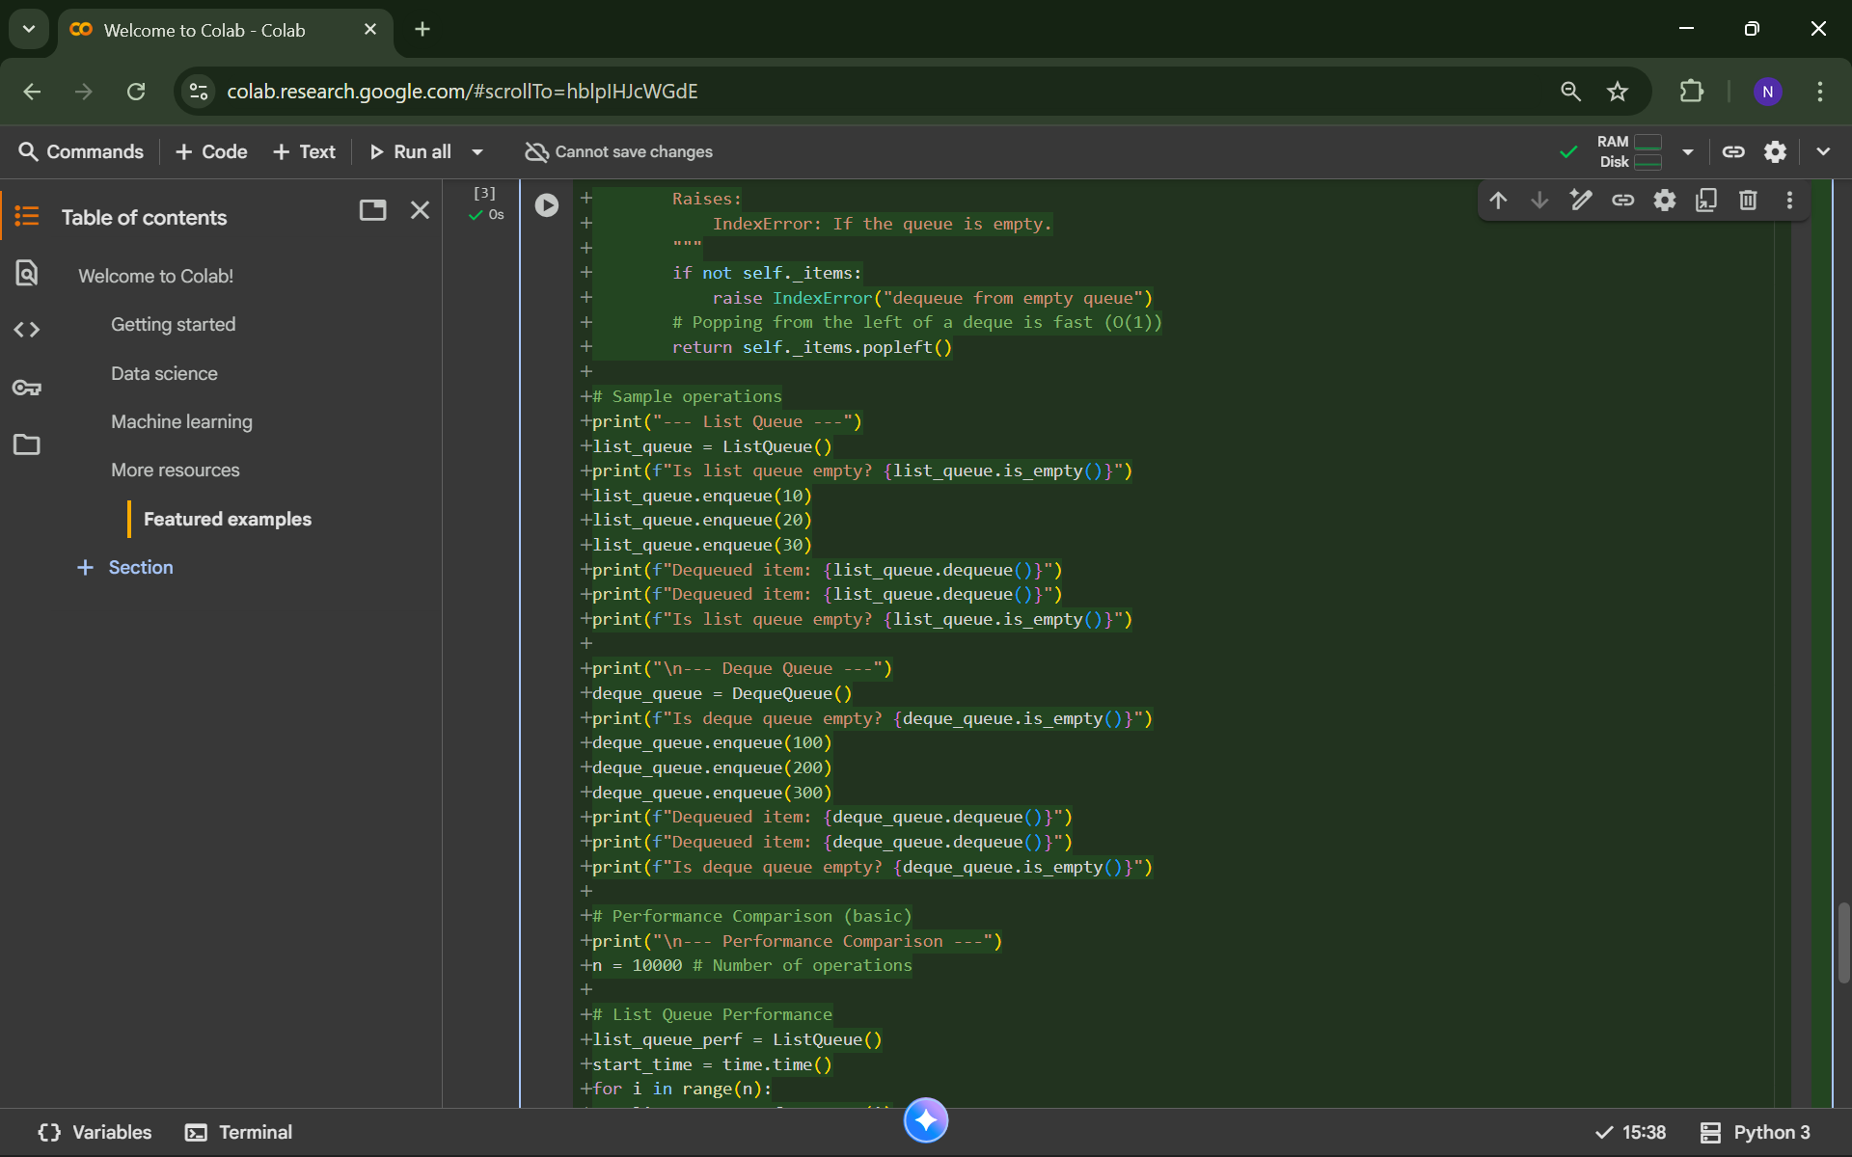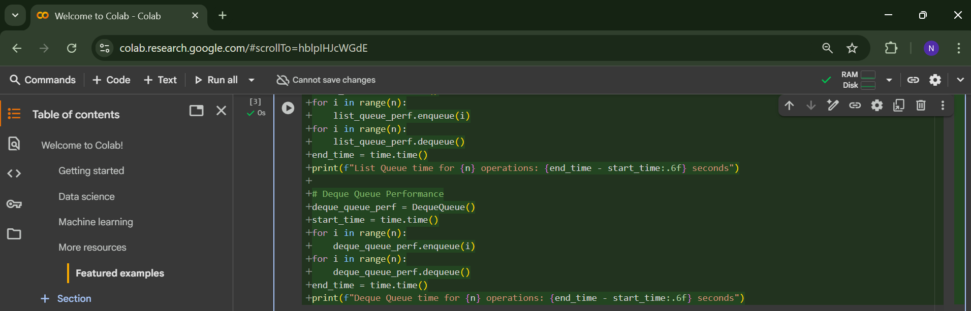

**OUTPUT:**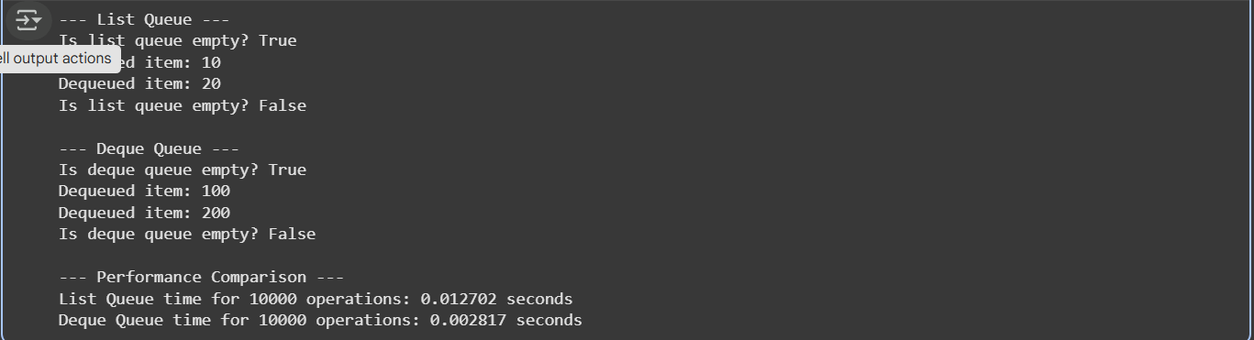

**Task 3: Singly Linked List with Traversal**

**PROMPT:**

1. Create a Python Singly Linked List (Node and LinkedList) with insert_at_end(), delete_value(), and traverse(). Add comments explaining pointer changes, include docstrings, and suggest test cases covering edge cases

**CODE:**

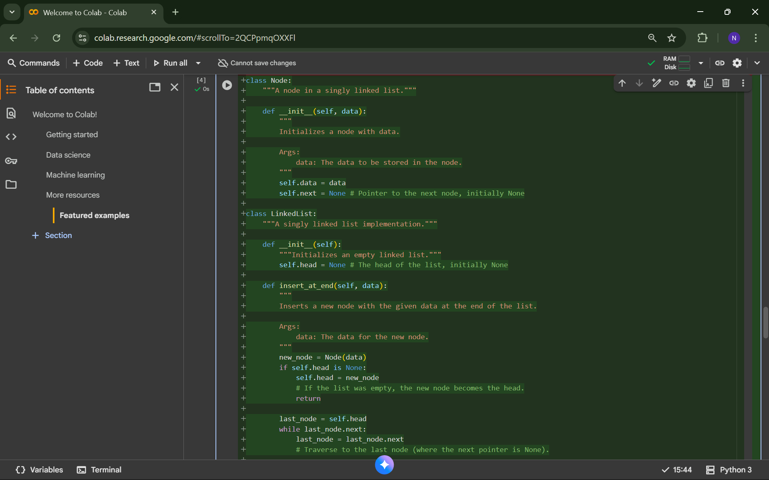

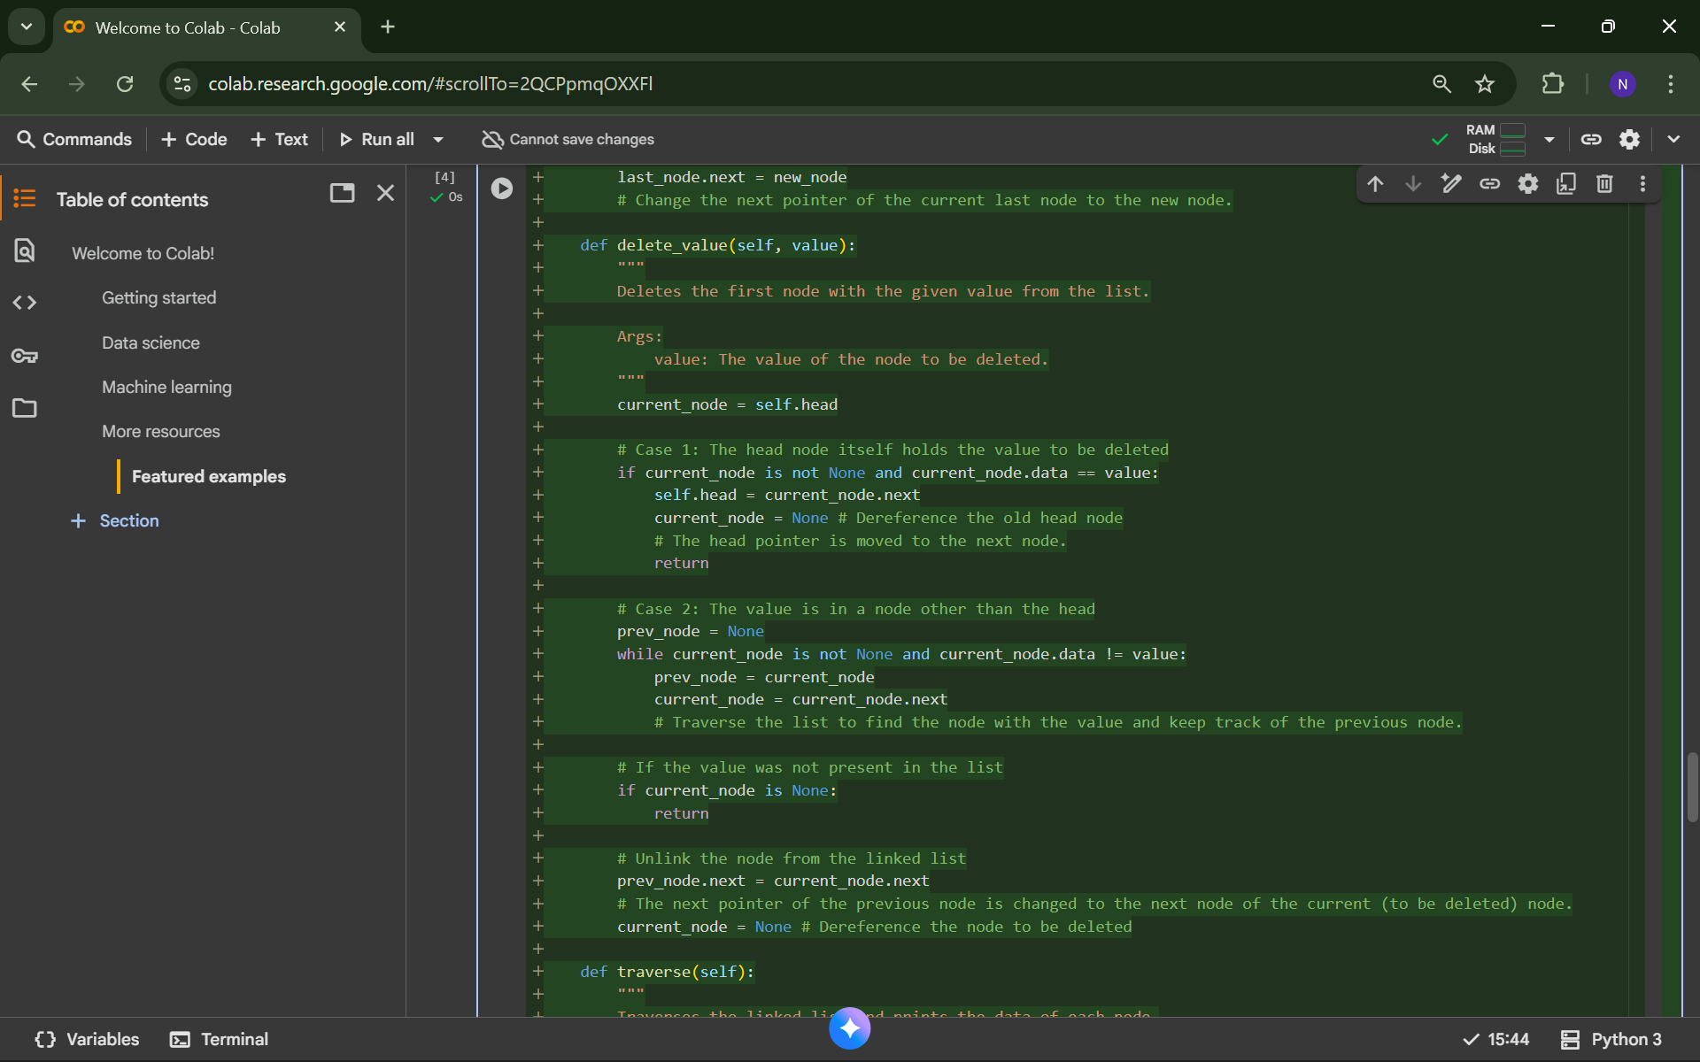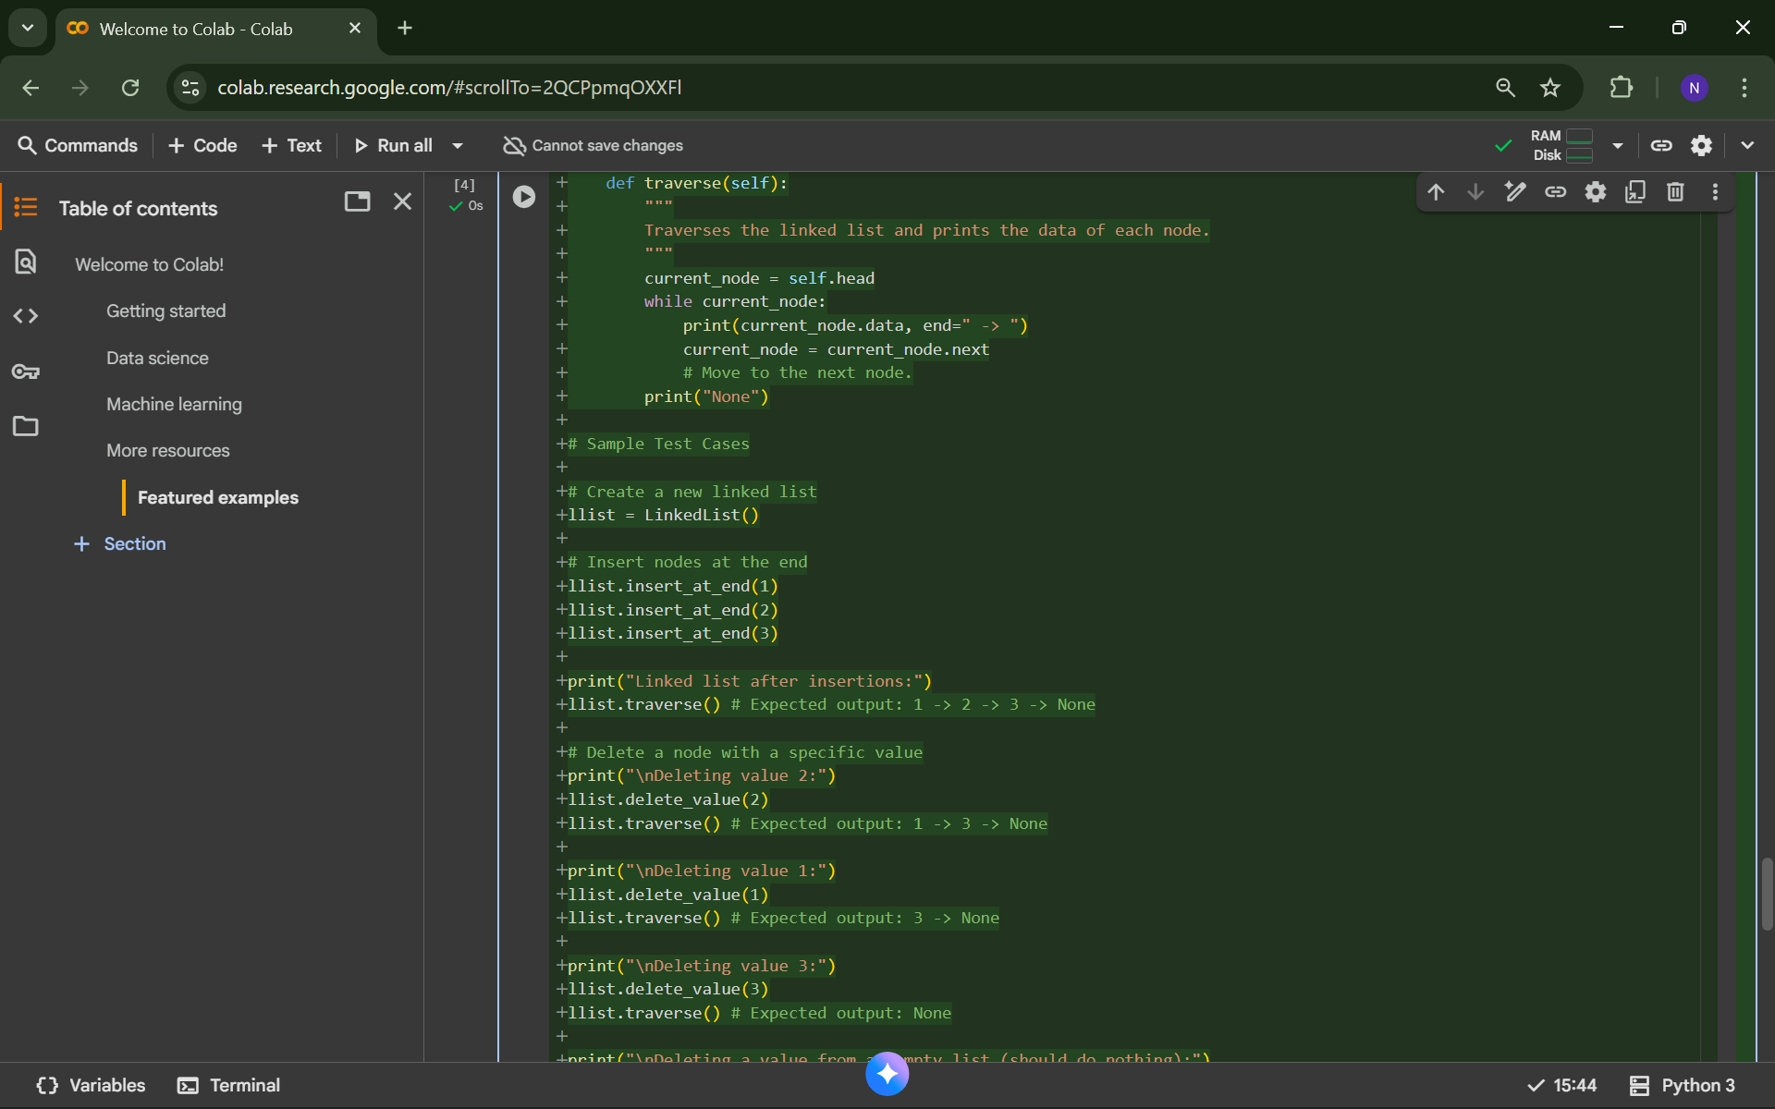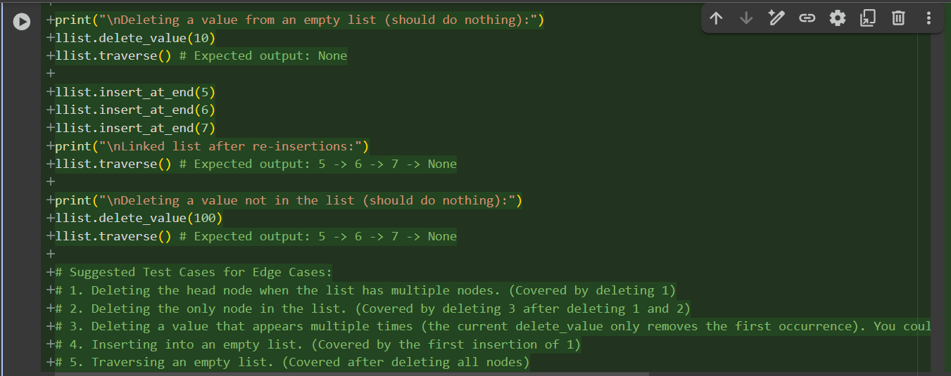

**OUTPUT:**

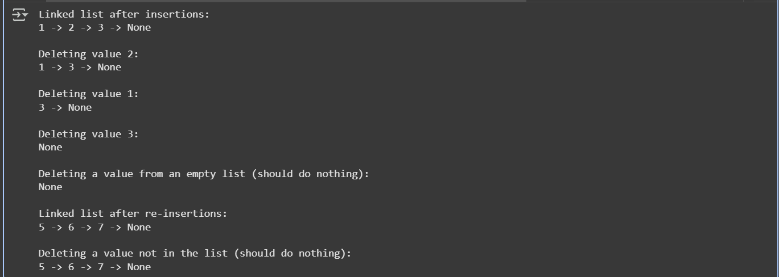

**Task 4: Binary Search Tree (BST)**

**PROMPT:**

1. Complete a Binary Search Tree with insert(), search(), and inorder_traversal(), assuming a Node class already exists. Include docstrings, test with a list of integers, check search for present and absent values, and print an inorder traversal

**CODE:**

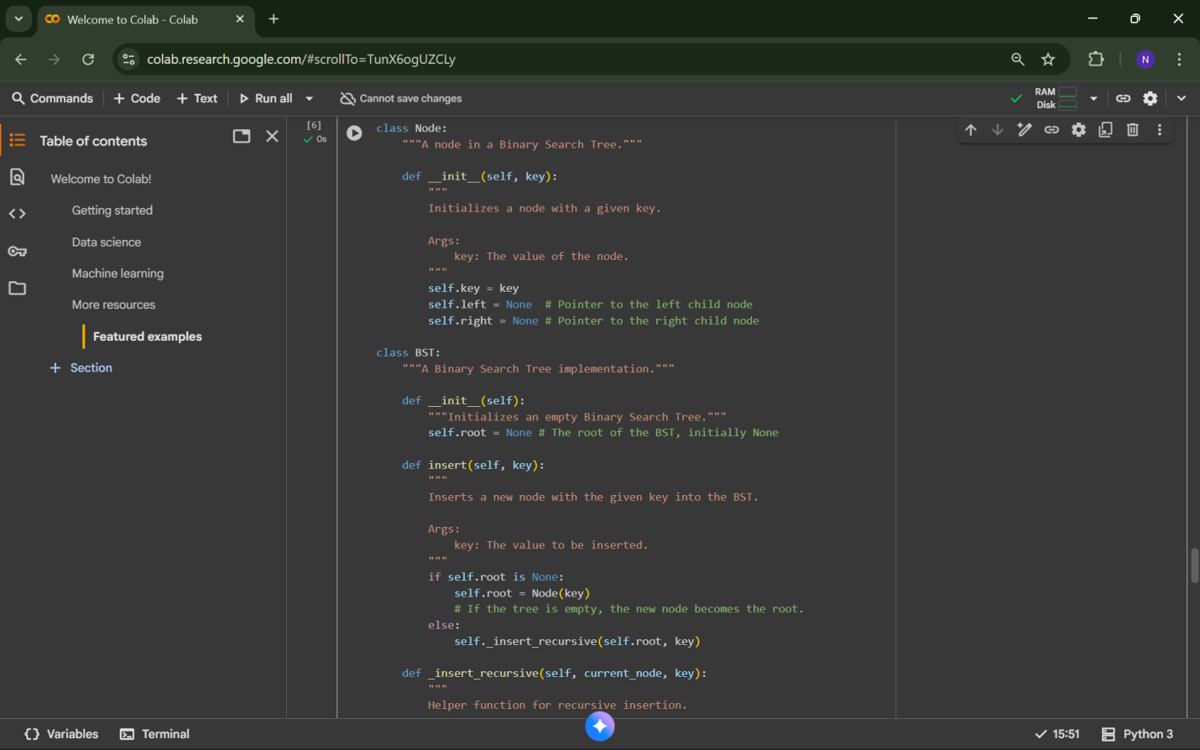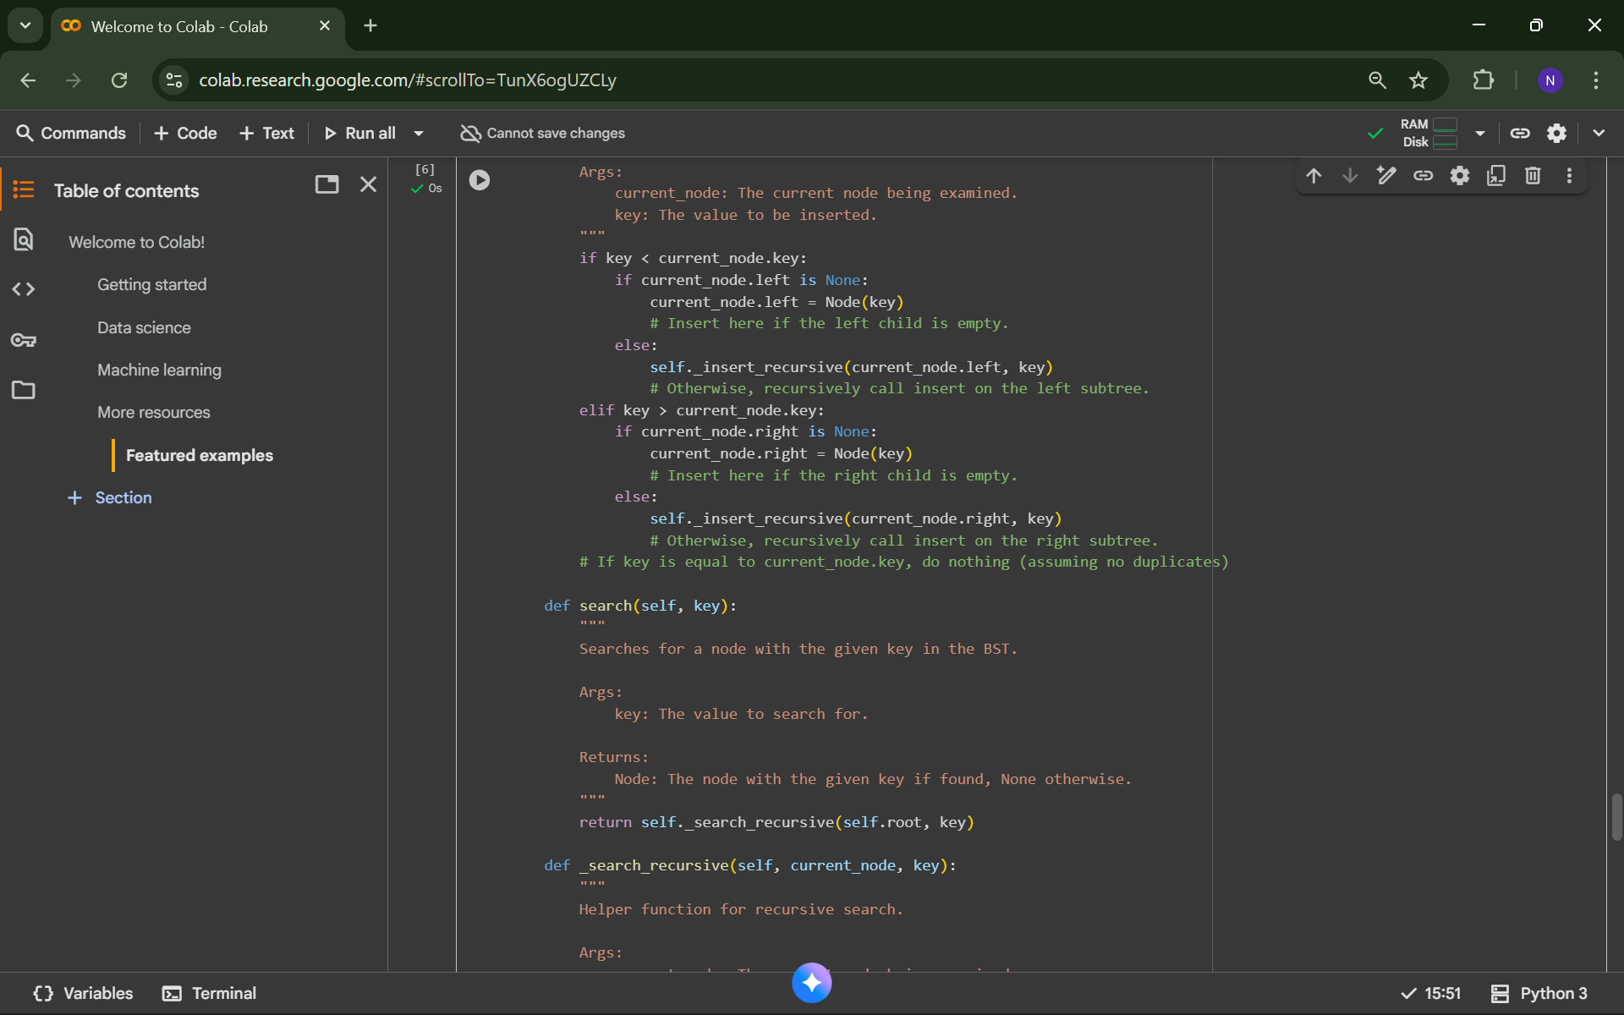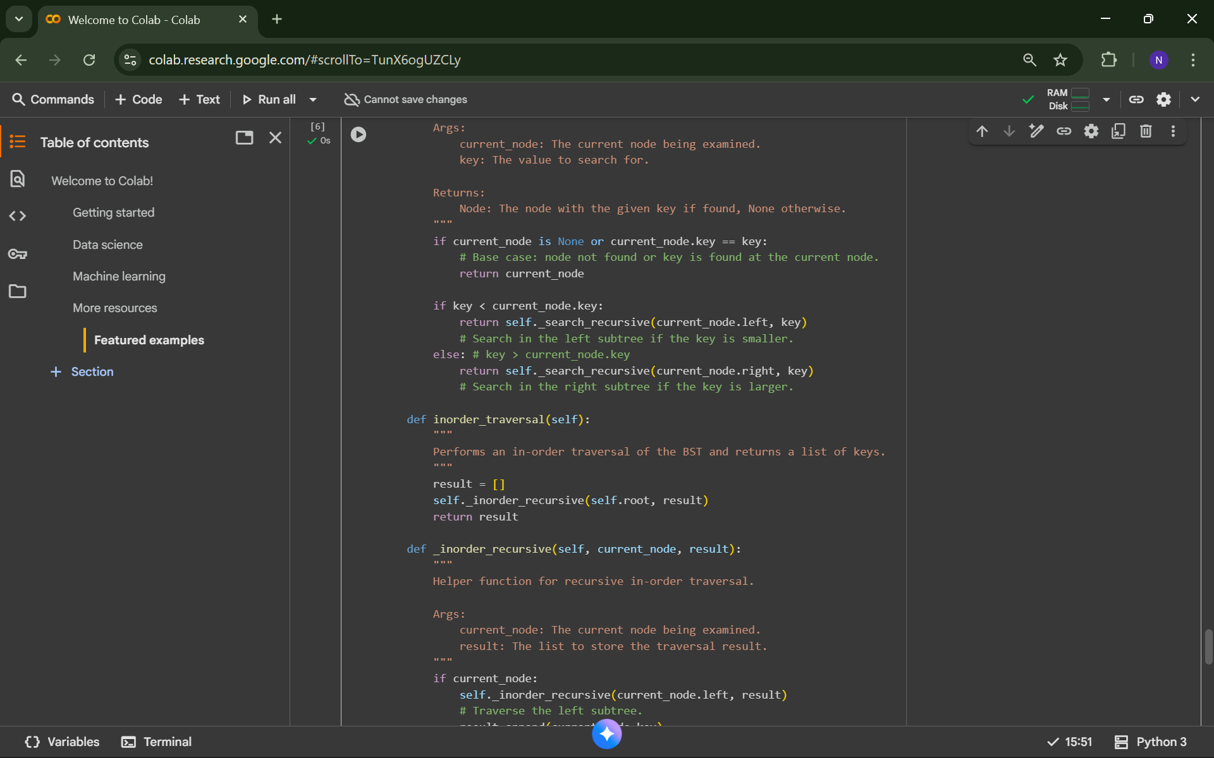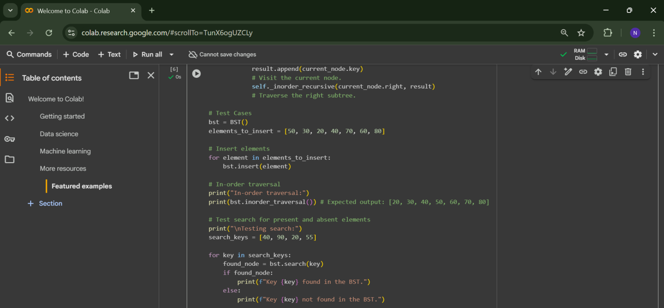

**OUTPUT:**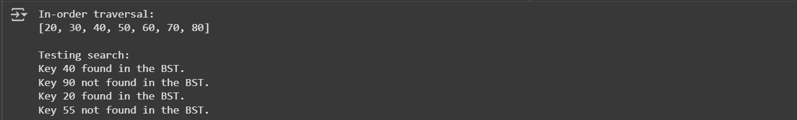

**Task 5: Graph Representation and BFS/DFS Traversal**

**PROMPT:**

1. Implement a Graph using an adjacency list with BFS() and DFS(). Add docstrings and comments explaining each step, show both recursive and iterative DFS, and demonstrate BFS/DFS outputs on sample data

**CODE:**

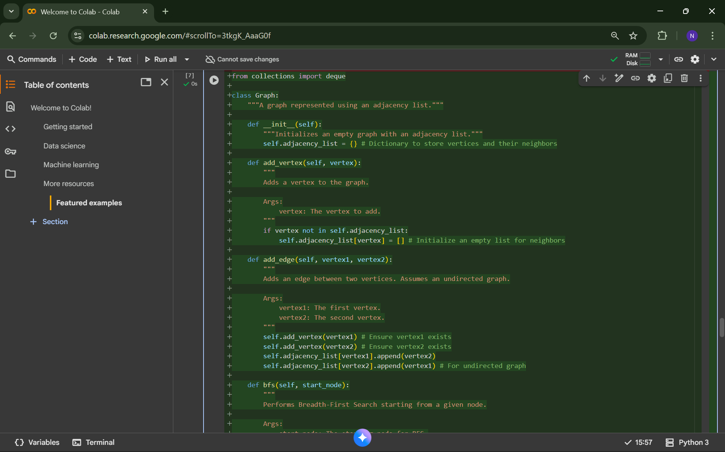

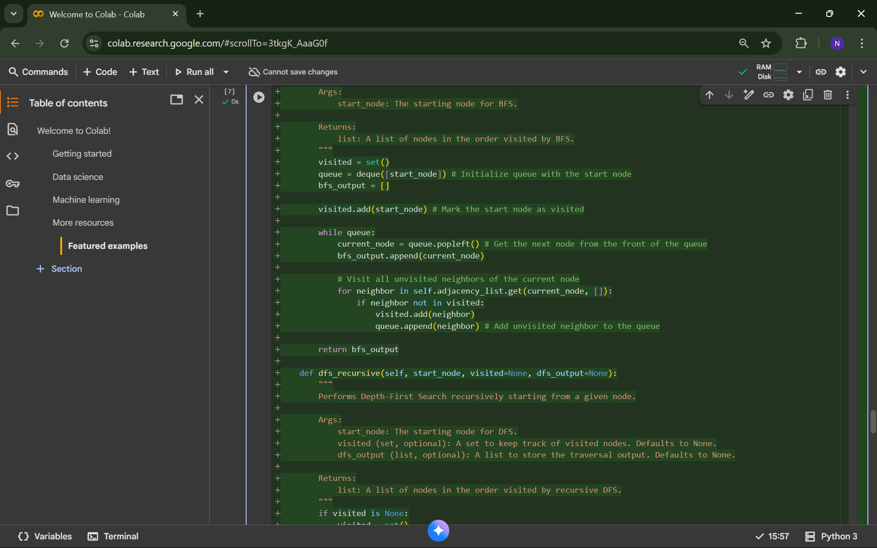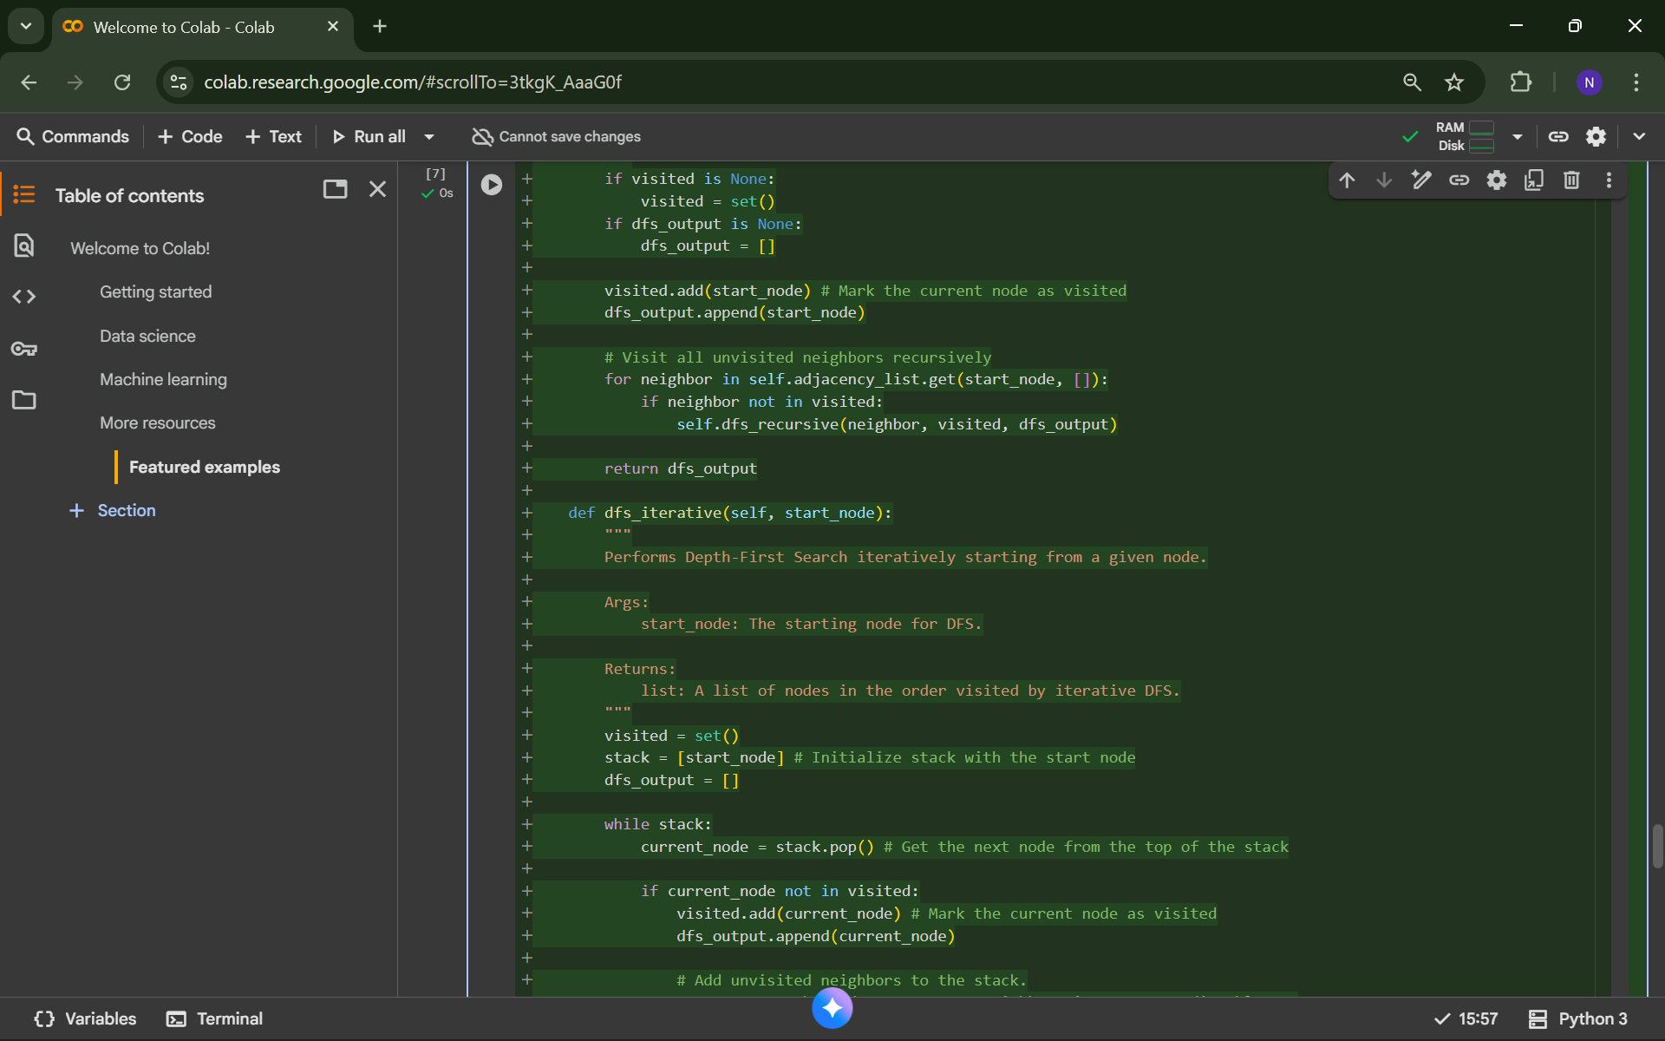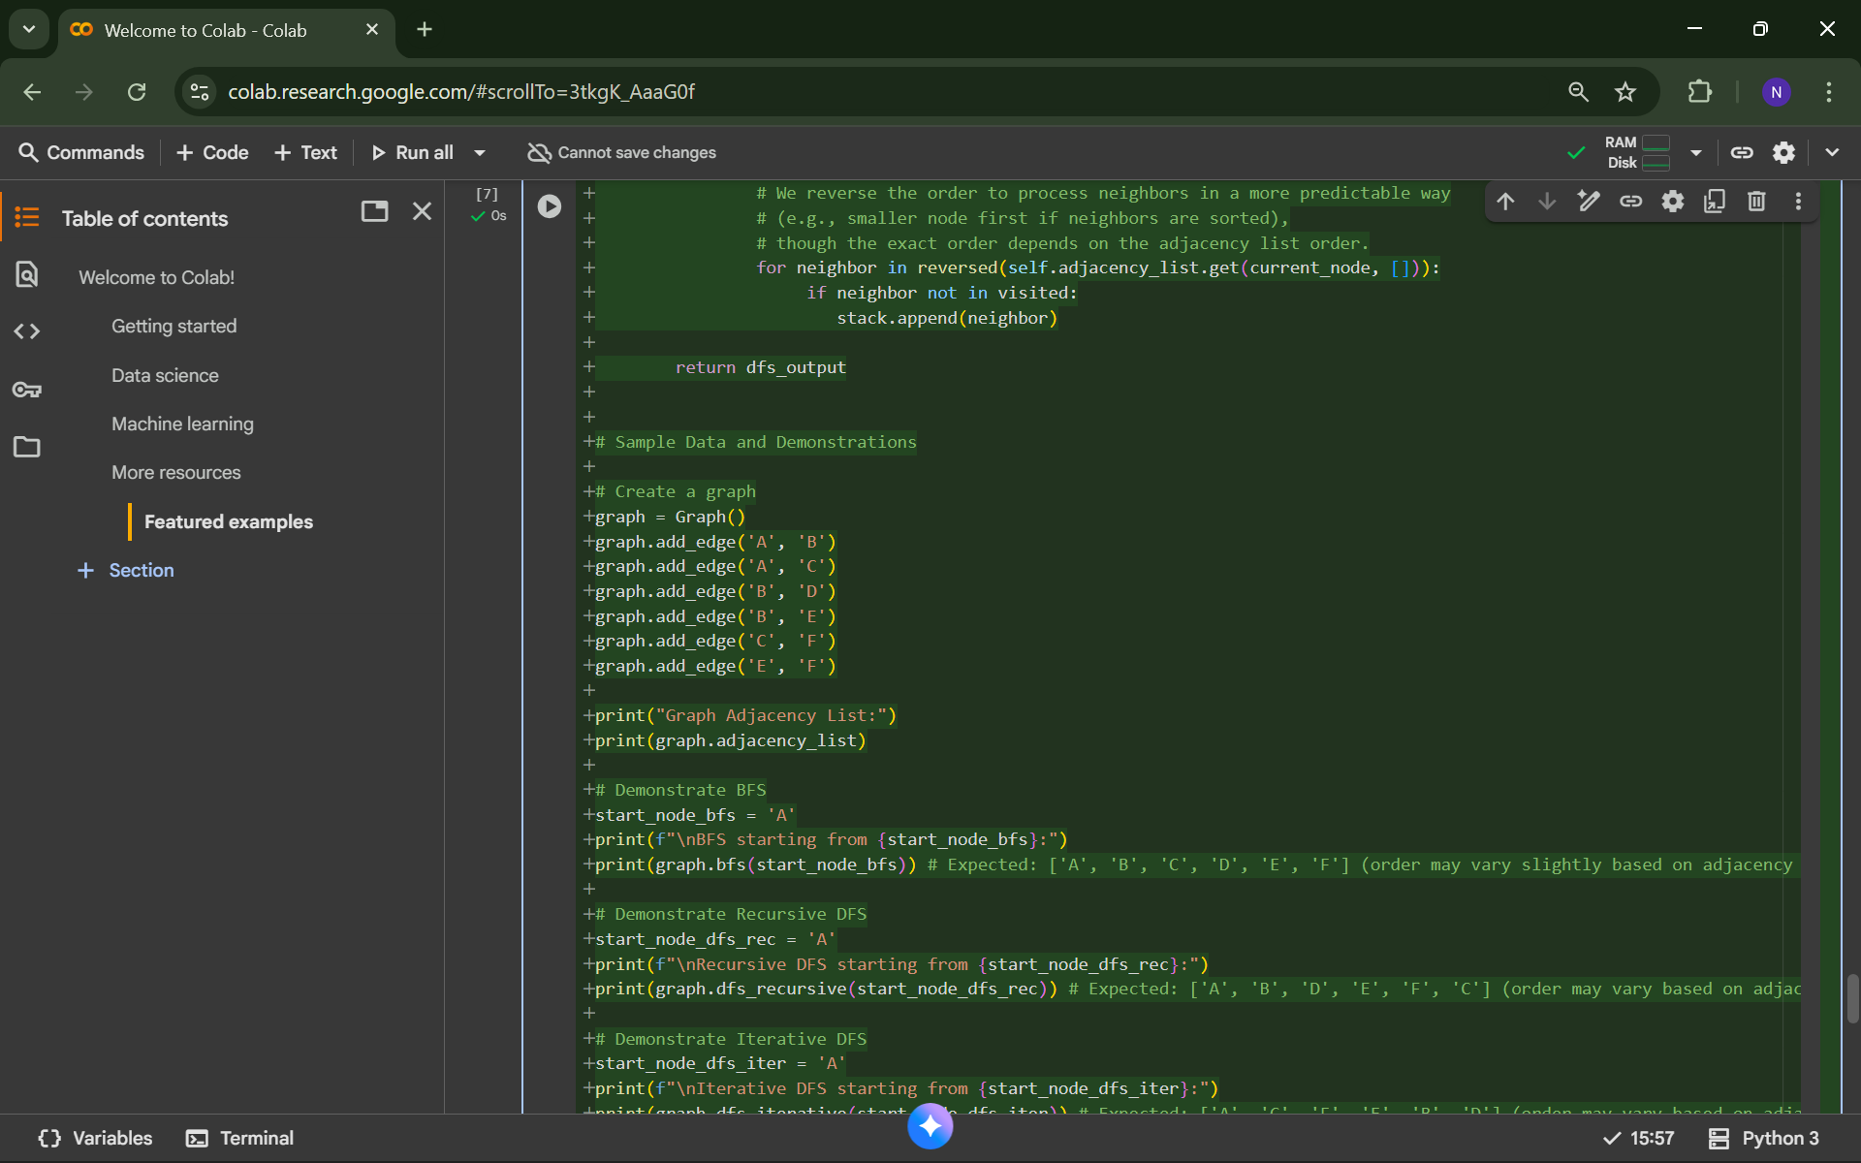

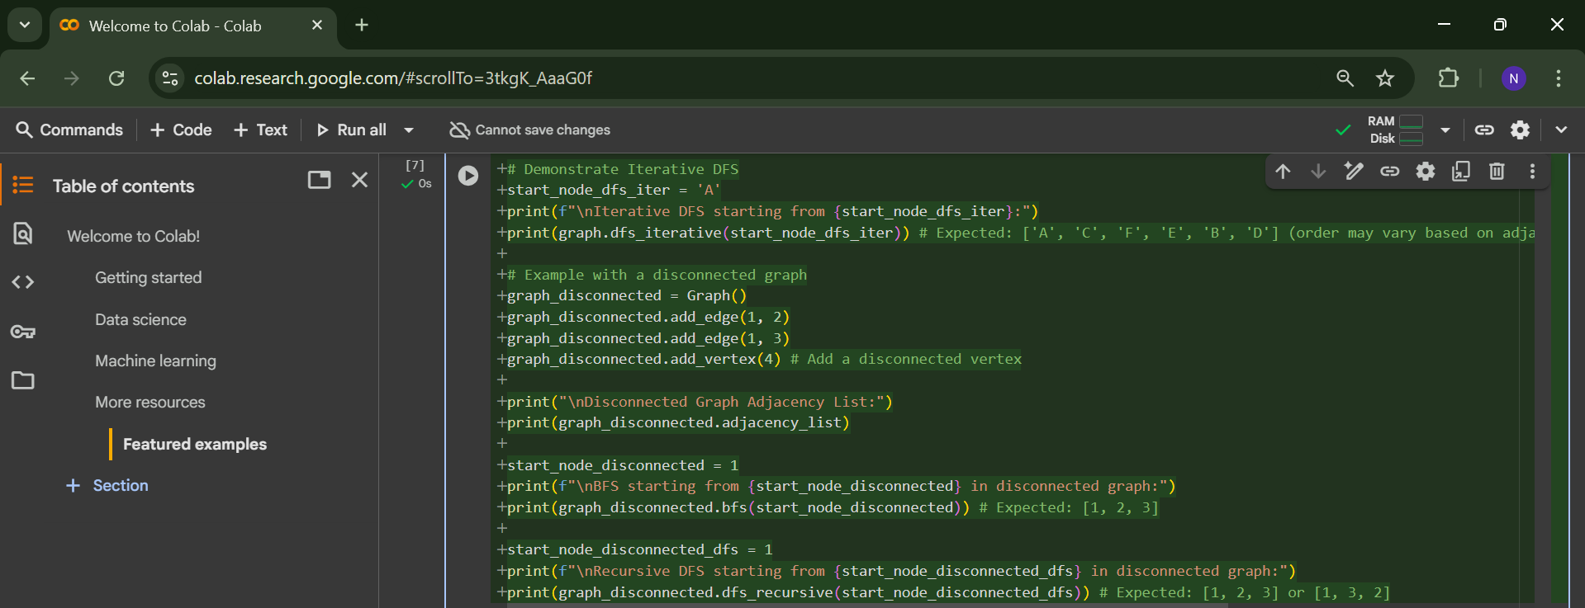

**OUTPUT:**

